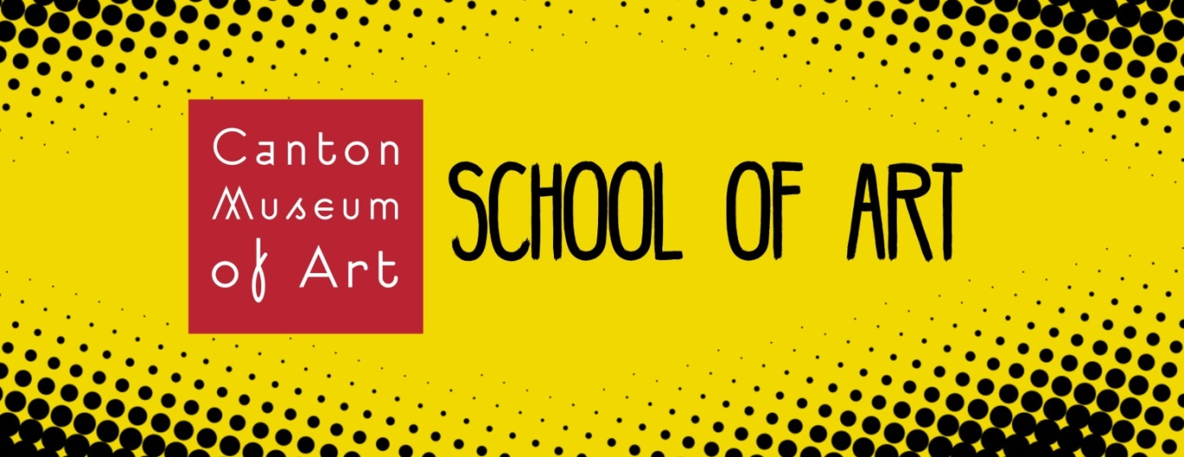

Canton Museum of Art
Scholarship Application Information
No one should be discouraged from applying to the Canton Museum of Art School of Art classes because of lack of funds. Through generous donations from donors, a limited number of scholarships are available for students ages 6-Adult who meet special criteria including financial and artistic need. These scholarships are intended to help provide outstanding artists assistance to further their artistic development who believe in their abilities to succeed!
Scholarships are available for ages 6-Adult for all 6-12 week classes and Summer Camps
Students 14 and up are encouraged to take adult classes
For a full list of class offerings visit: www.cantonart.org/learn
HOW TO APPLY
- Please fill out the following application for each applicable student and return by email to: erica@cantonart.org with the subject “Scholarship”
- Applications are accepted year round and considered on a case by case basis.
- Once submitted, applicants will be notified within two weeks of receiving the application if they have been awarded a scholarship.

CHILDREN SCHOLARSHIPS ARE MADE POSSIBLE IN PART THROUGH SUPPORT FROM THE HOOVER FOUNDATION.
ADULT SCHOLARSHIPS ARE MADE POSSIBLE IN PART BY SUPPORT FROM THE ANTHONY J. AND SUSAN E. PAPARELLA FOUNDATION.
For more information about scholarships, please contact:
Erica Emerson, Education Director, at 330-453-7666 ext.108, erica@cantonart.org
APPLICANT INFO
Student Name: __________________________________________
Student Age: ______
Student Grade: _______
Please describe any special needs you or your student may have: ____________________________________________________________________________________________________________________________________________________________
Parent/Guardian Name: __________________________________________
Address: ______________________________________________________________
Cell: ____________________
Home Phone: __________________
Email: __________________________________________

REQUESTED Class ScHolarship
Class Title:_____________________________________________-
Start Date of Class:_______________________

Have you or your student taken a CMA class or camp before?
YES
NO

Have you or your student received a School of Art scholarship before?
YES
NO

FAMILY INCOME
Household income (before taxes):_____________________________________
Number of individuals in household: _________

Why do you or your student want to attend a class at CMA? ______________________________________________________________________________________________________________________________________________________________________________________________________________________________________________________________________________________________________________________________________________________________________________________________________

Why do you believe you or your student should receive a School of Art Scholarship? ______________________________________________________________________________________________________________________________________________________________________________________________________________________________________________________________________________________________________________________________________________________________________________________________________

